FORCES AND MOTION: Basics

Open up PhET simulation “Forces and Motion.”

TASK 1
- Place 2 people that are the same size the same distance away from the cart.
- Make a prediction about the movement of the cart.
- AFTER you have observed the actual movement, click on the sum of the forces box at the top right hand corner of the simulation. Record the number in the data chart.

 | Predicted Movement | Actual Movement  (none, left, right) | Sum of Forces  (0, x-left, x-right)
Same size, same placement on rope.
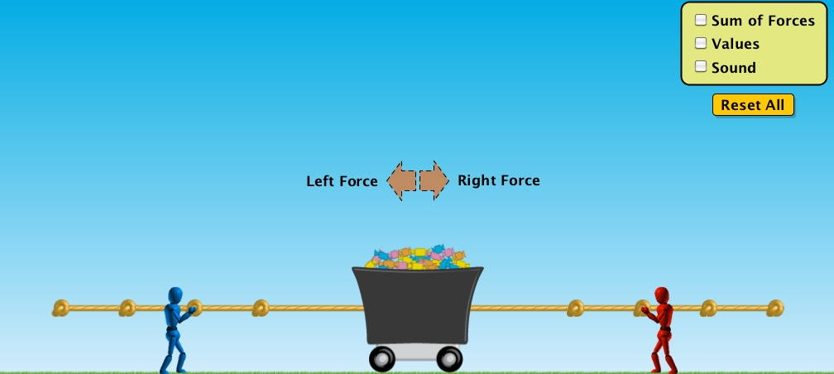

TASK 2
- Place 2 people that are the same size different distances away from the cart.
- Make a prediction about the movement of the cart.
- AFTER you have observed the actual movement, click on the sum of the forces box at the top right hand corner of the simulation. Record the number in the data chart.

 | Predicted Movement | Actual Movement  (none, left, right) | Sum of Forces  (0, x-left, x-right)
Same size, different placement on rope.
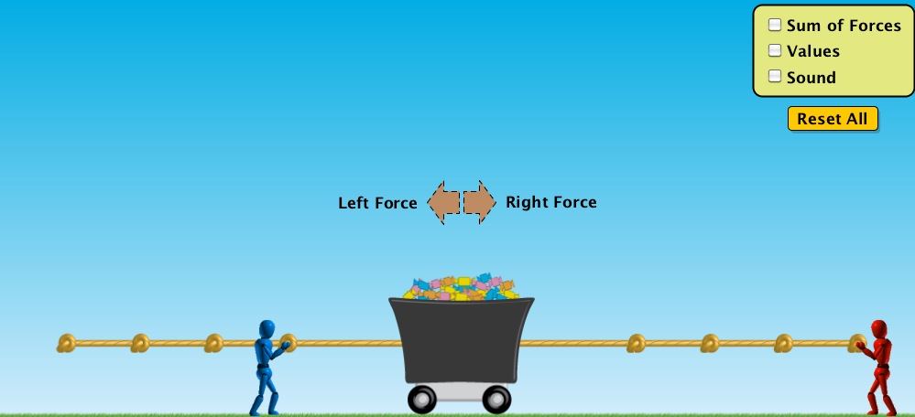

TASK 3
- Place 2 people that are different sizes the same distance away from the cart.
- Make a prediction about the movement of the cart.
- AFTER you have observed the actual movement, click on the sum of the forces box at the top right hand corner. Record the number in the data chart.

 | Predicted Movement | Actual Movement  (none, left, right) | Sum of Forces  (0, x-left, x-right)
Different size, same placement on rope.
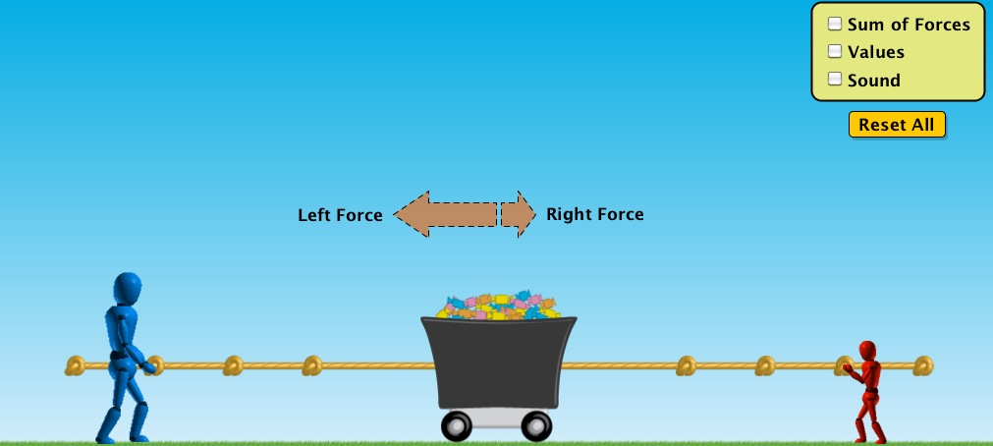

TASK 4
- Place 2 people that are the different sizes different distances away from the cart.
- Make a prediction about the movement of the cart.
- AFTER you have observed the actual movement, click on the sum of the forces box at the top right hand corner of the simulation. Record the number in the data chart.

 | Predicted Movement | Actual Movement  (none, left, right) | Sum of Forces  (0, x-left, x-right)
Different size, different placement on rope.